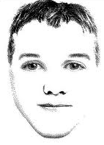
Introduction
There are a wide variety of traits present in the human population. Below is a list of facial characteristics and the possible phenotypes and genotypes that can be inherited for each.

- Genotype= the actual genetic makeup (the genes) of an individual
- Phenotype= the form of the trait that is observed; many times this is physical appearance.

There is a certain type of gene that determines every individual trait (such as different eye colors or the ability to roll your tongue); these genes are called alleles.

- Alleles= different forms of a gene for the same trait. For example, blue vs. brown eyes (these are both alleles for the eye color gene).

Alleles can either be recessive or dominant and are written using uppercase and lowercase letters. Each parent donates one allele so a child has two alleles, or one pair. There are 3 possible combinations for a trait with 2 alleles:

- Both dominant (EE)= called homozygous dominant. “Homo” refers to “same”.
- Both recessive (ee)= called homozygous recessive.
- One dominant and one recessive (Ee)= heterozygous. “Hetero” refers to “different”.

Even though a heterozygous individual has both dominant and recessive alleles in their genotype, they will usually only express the dominant trait for their phenotype.

The only way an individual will show a recessive trait, is when they are homozygous recessive, meaning they received the recessive gene from each of their parents.

Directions: Look at your face and highlight or circle the characteristics which best describe yourself for each trait listed below. It is helpful to look in a mirror or work with a partner and help each other.

- Sex: Female (XX); Male (XY)
(Sex is determined by the male’s sex chromosome; we will study this more later.)
- Face shape: Round face (RR, Rr); Square face (rr)
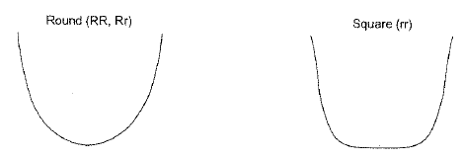
- Chin shape: Very prominent chin (VV, Vv); Average chin (vv)
(Very prominent means they have a ‘big chin’ that stands out as a major feature… Think Jay Leno)
- Jawline shape: Rounded chin (RR, Rr); Square chin (rr)
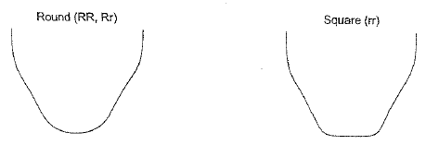
- Cleft chin: absent (AA, Aa); Cleft chin present- dimple on chin (aa)
(Cleft chin means they have a dimple on their chin… Think Jessica Simpson)
- Hair shape: Curly Hair (HH); Wavy hair (Hh); Straight hair (hh)
- Widow’s Peak: present (PP, Pp); Widow’s peak absent (pp)
(Widow’s peak means your hairline comes to a point on the center of your forehead … Think Addam’s Family)
- Hair Color: (This is a polygenic trait which we will study more in the next chapter)
Black hair (AABB, AABb); Brown hair (AaBB, AaBb); Red Hair (AAbb);
Dark blonde (aaBB); Blonde (Aabb, aaBb); Light blonde (aabb)
- Eyebrow thickness: Thick eyebrows (BB, Bb); Thin eyebrows (bb)
- Eyebrows connectedness: Not connect eyebrows (NN, Nn); Connected eyebrows (nn)
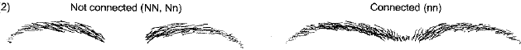
- Color of Eyebrows: Darker than hair (HH); Same as hair (Hh); lighter than hair (hh)
- Eye distance: Eyes close together (EE); Average distance between eyes (Ee); Far distance between eyes (ee)
- Eye size: Large eyes (LL); Medium-sized or average eyes (Ll); Small eyes (ll)
- Eye Shape: Almond eye shape (AA, Aa); Round eyes (aa)
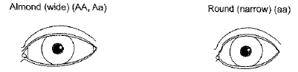
- Eye position: Horizontal eye slant (HH, Hh); Upward eye slant (hh)
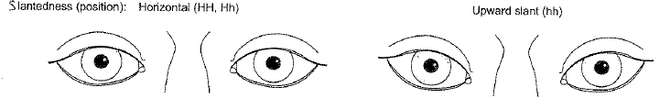
- Eye Color: (This is also a polygenic trait which we will study in the next chapter)
Dark brown (AABB, AABb); Brown (AAbb, AaBb); Hazel (AaBB);
Gray-blue (Aabb); Green (aaBB); Dark blue (aaBb); Light blue (aabb)
- Eye lashes: Long eye lashes (LL, Ll); Short eye lashes (ll)
- Mouth size: Long mouth (MM); Average-size mouth (Mm); Small mouth (mm)
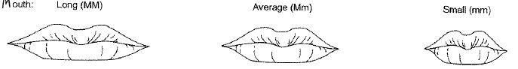
- Lip size: Thick lips (TT, Tt); Thin lips (tt)
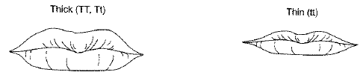
- Hapsburg lip/jaw: Lower jaw or lip protrudes farther out than upper lip (HH);
slight Hapsburg lip/jaw (Hh); Hapsburg lip/jaw Absent (hh)
(Look at the person from the side, does their upper or lower lip stick out farther? Hapsburg is when the
lower jaw or lip protrudes farther out than upper lip)

- Cheek dimple(s): Dimple(s) present (DD, Dd); Cheek dimples are absent (dd)
- Nose size: Big Nose (NN); Medium-sized nose (Nn); Small nose (nn)
- Nose width: Wide nose (WW, Ww); Narrow Nose (ww)
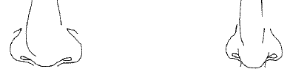
- Nose shape: Rounded nose-tip (RR, Rr); Pointed nose-tip (rr)
- Nostril shape: Rounded nostril shape (RR, Rr); Flared nostril shape (rr)
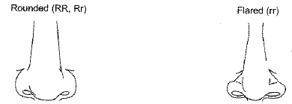
- Size of ears: Large ears (LL, Ll); Small ears (ll)

- Ear lobes: Free/unattached (FF, Ff); Attached (ff)
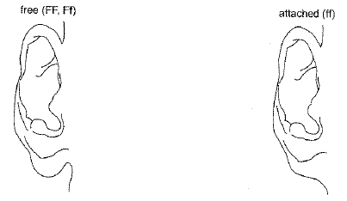
- Ear shape: Darwin’s Earpoint present (DD, Dd); Darwin’s Earpoint absent (dd)
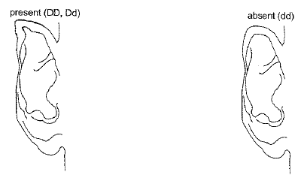
- Hairy ears: Ear hair absent (EE, Ee); Ear hair present (ee)
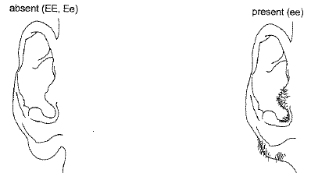
- Freckles on Face: present (FF, Ff); Freckles absent (ff)

Other Unique Inherited Traits:
31. White Forelock of Hair: White forelock of hair present (WW, Ww); No white forelock (ww)
32. Front tooth gap: Front tooth gap present (GG, Gg); No front tooth gap (gg)

* Keep this in your science notebook; it will be used for the next lab. *

